2026 Rockin’ the Porch Concert Series | 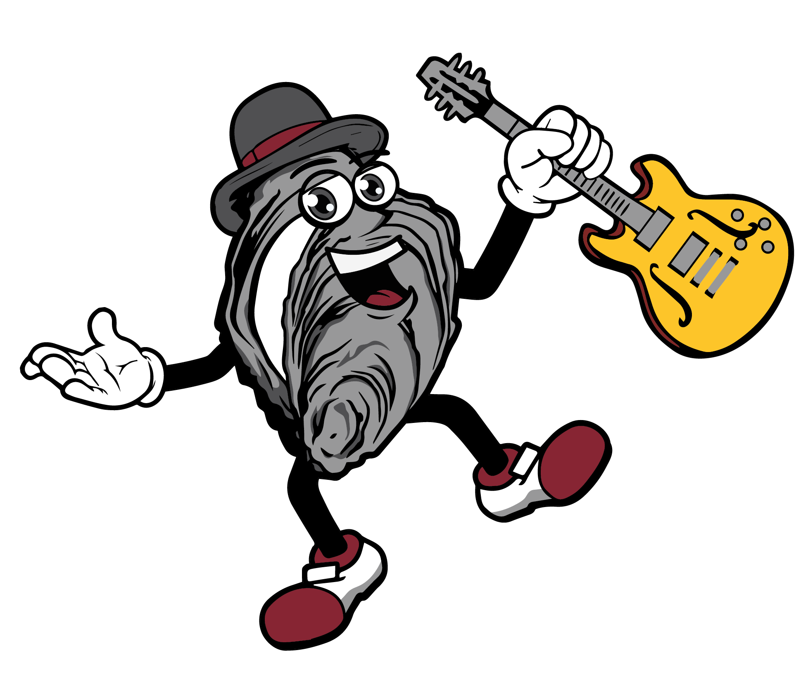
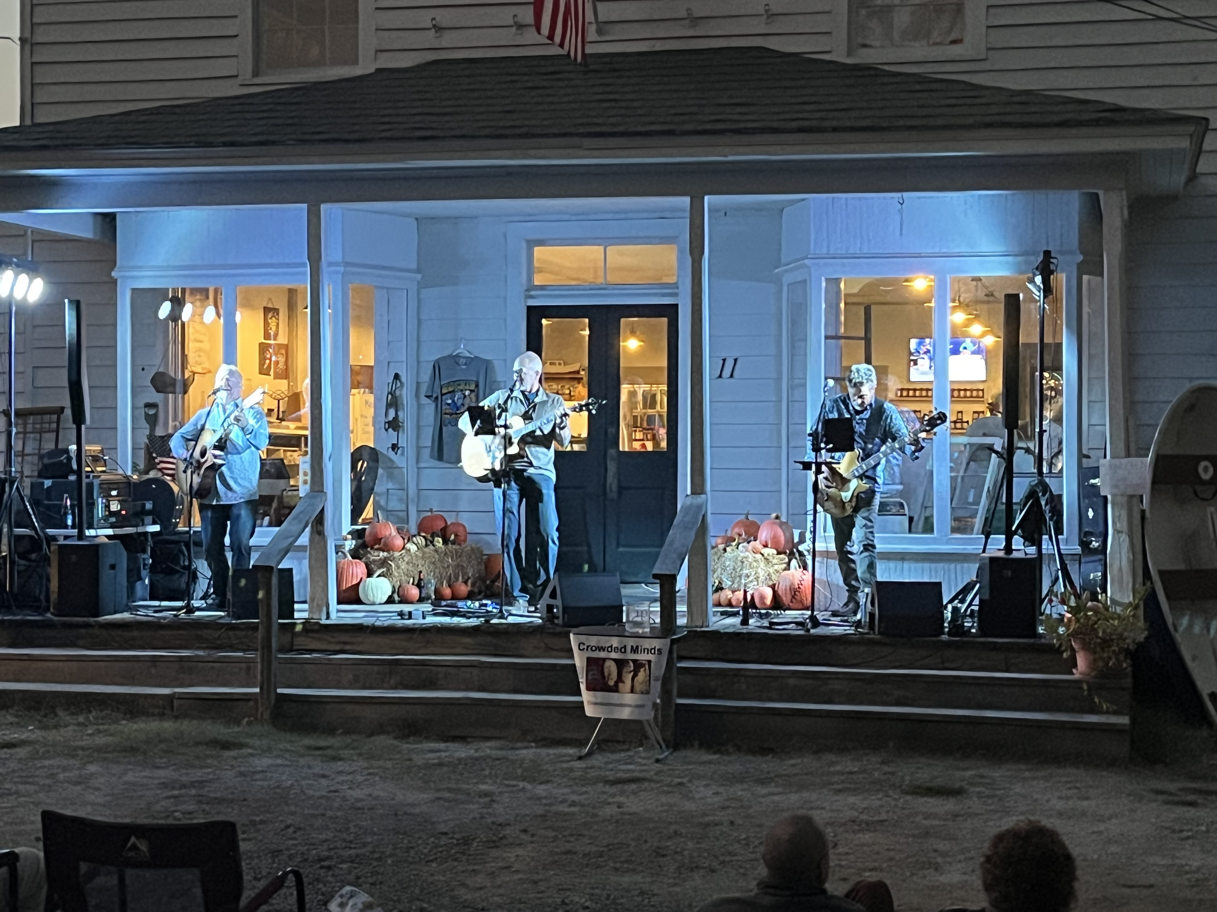 | 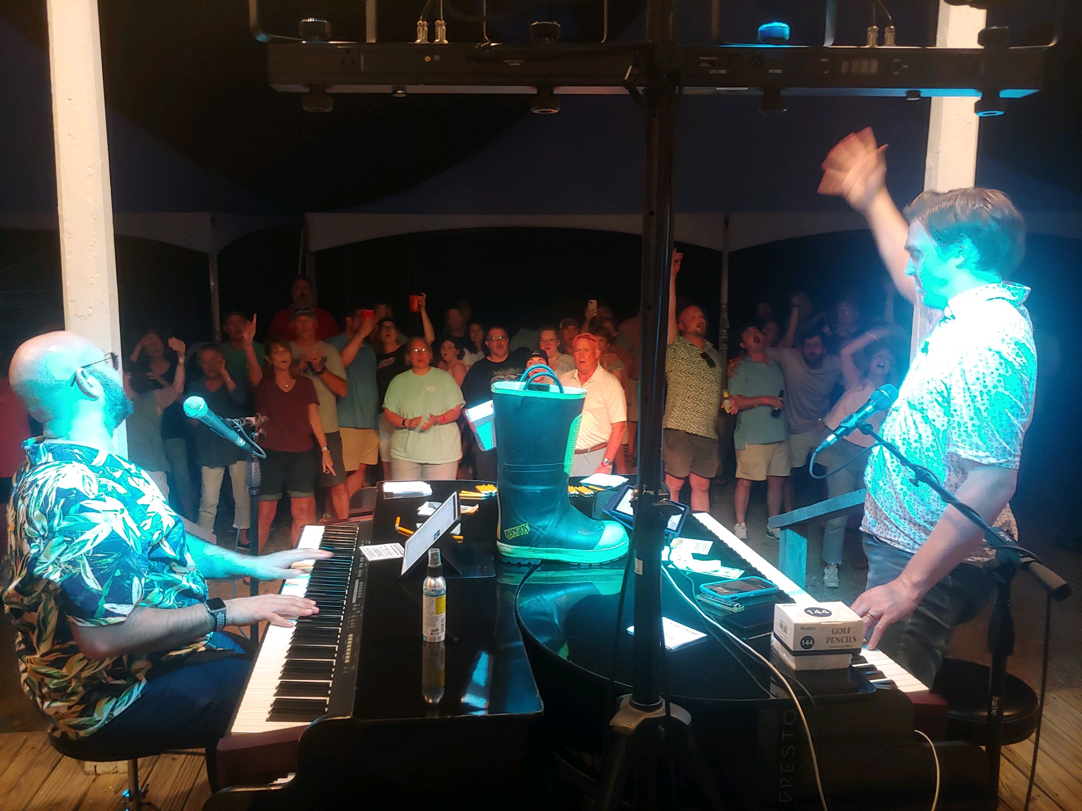

  - Become a 2026 Sponsor
Sponsoring Rockin’ the Porch at Kinsale Market is a fantastic way to showcase your business while supporting live music and community engagement. With a loyal and growing audience, your business will gain valuable exposure through event promotions, social media, and on-site recognition. Join us in creating unforgettable nights of music, connection, and local pride—let’s make this season one to remember!

5 Great Music Events and Exposure at the 5K
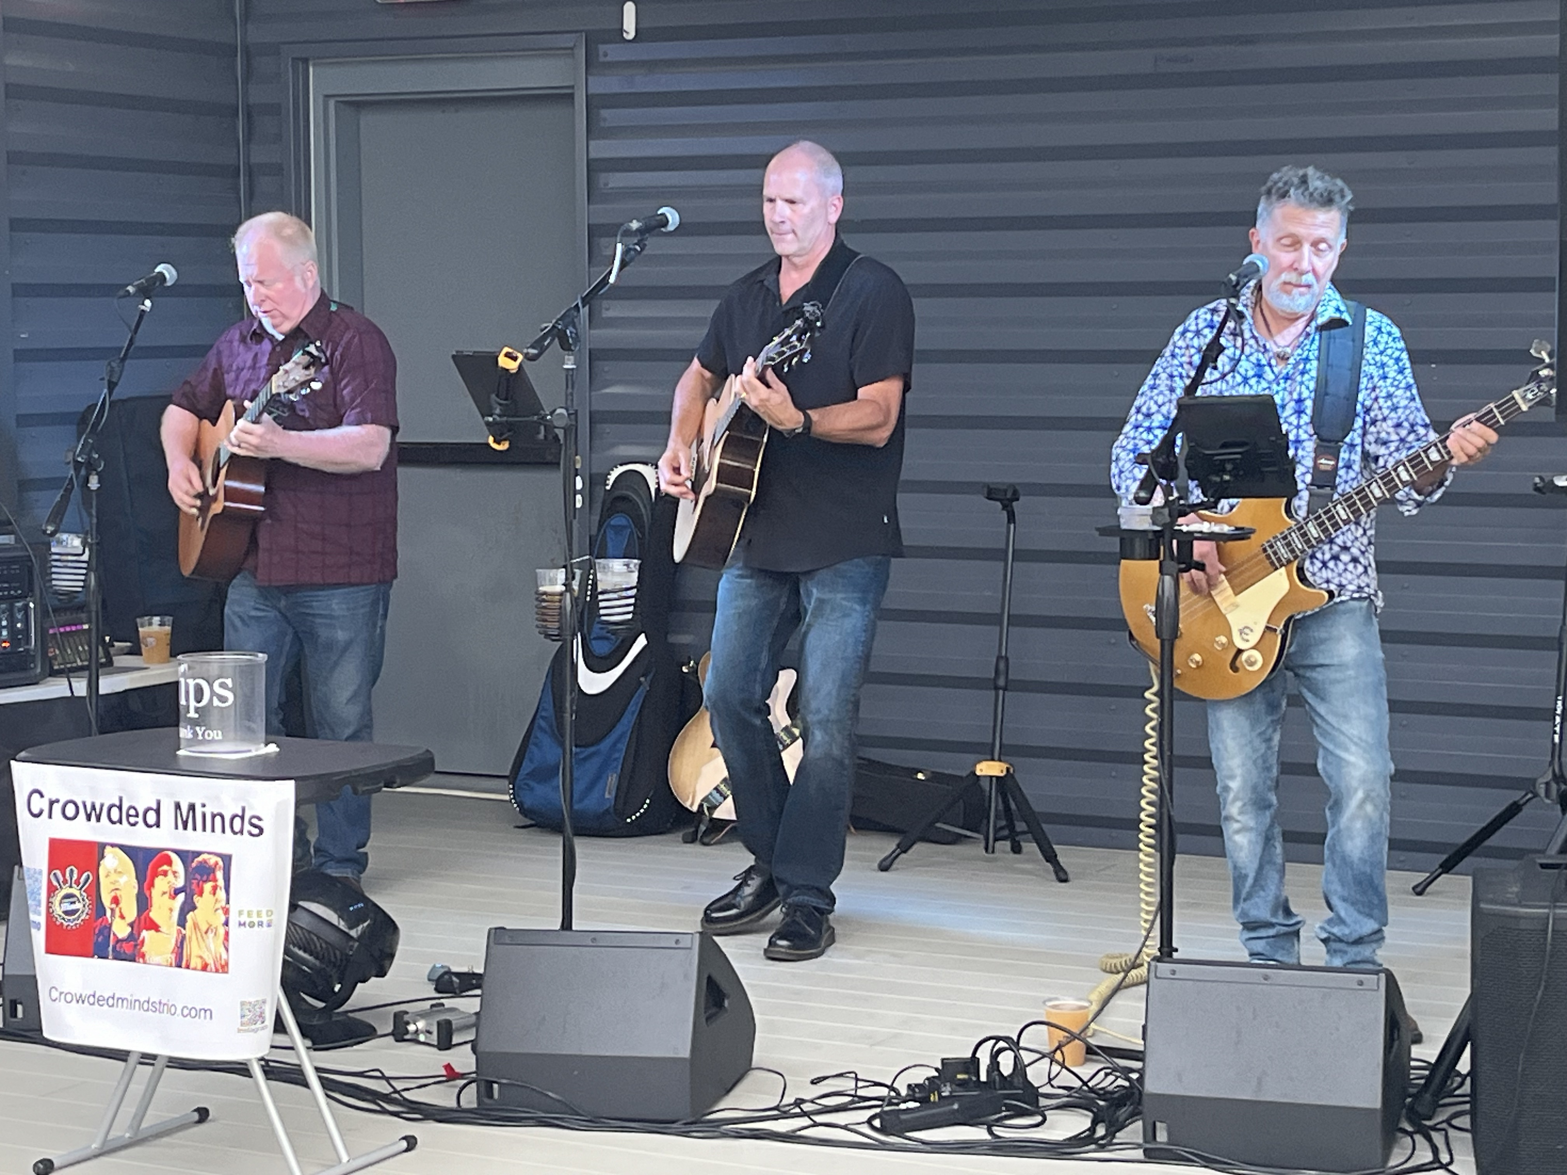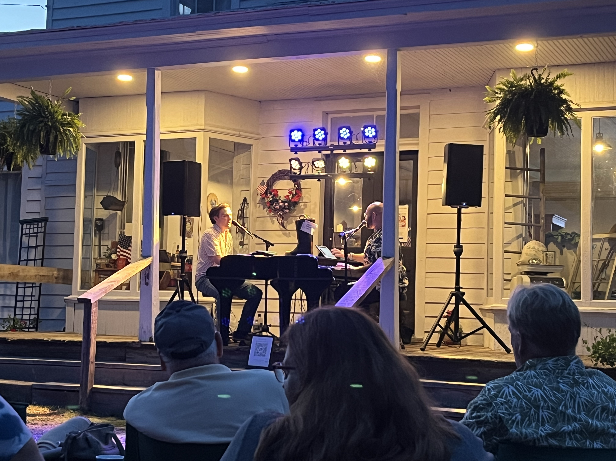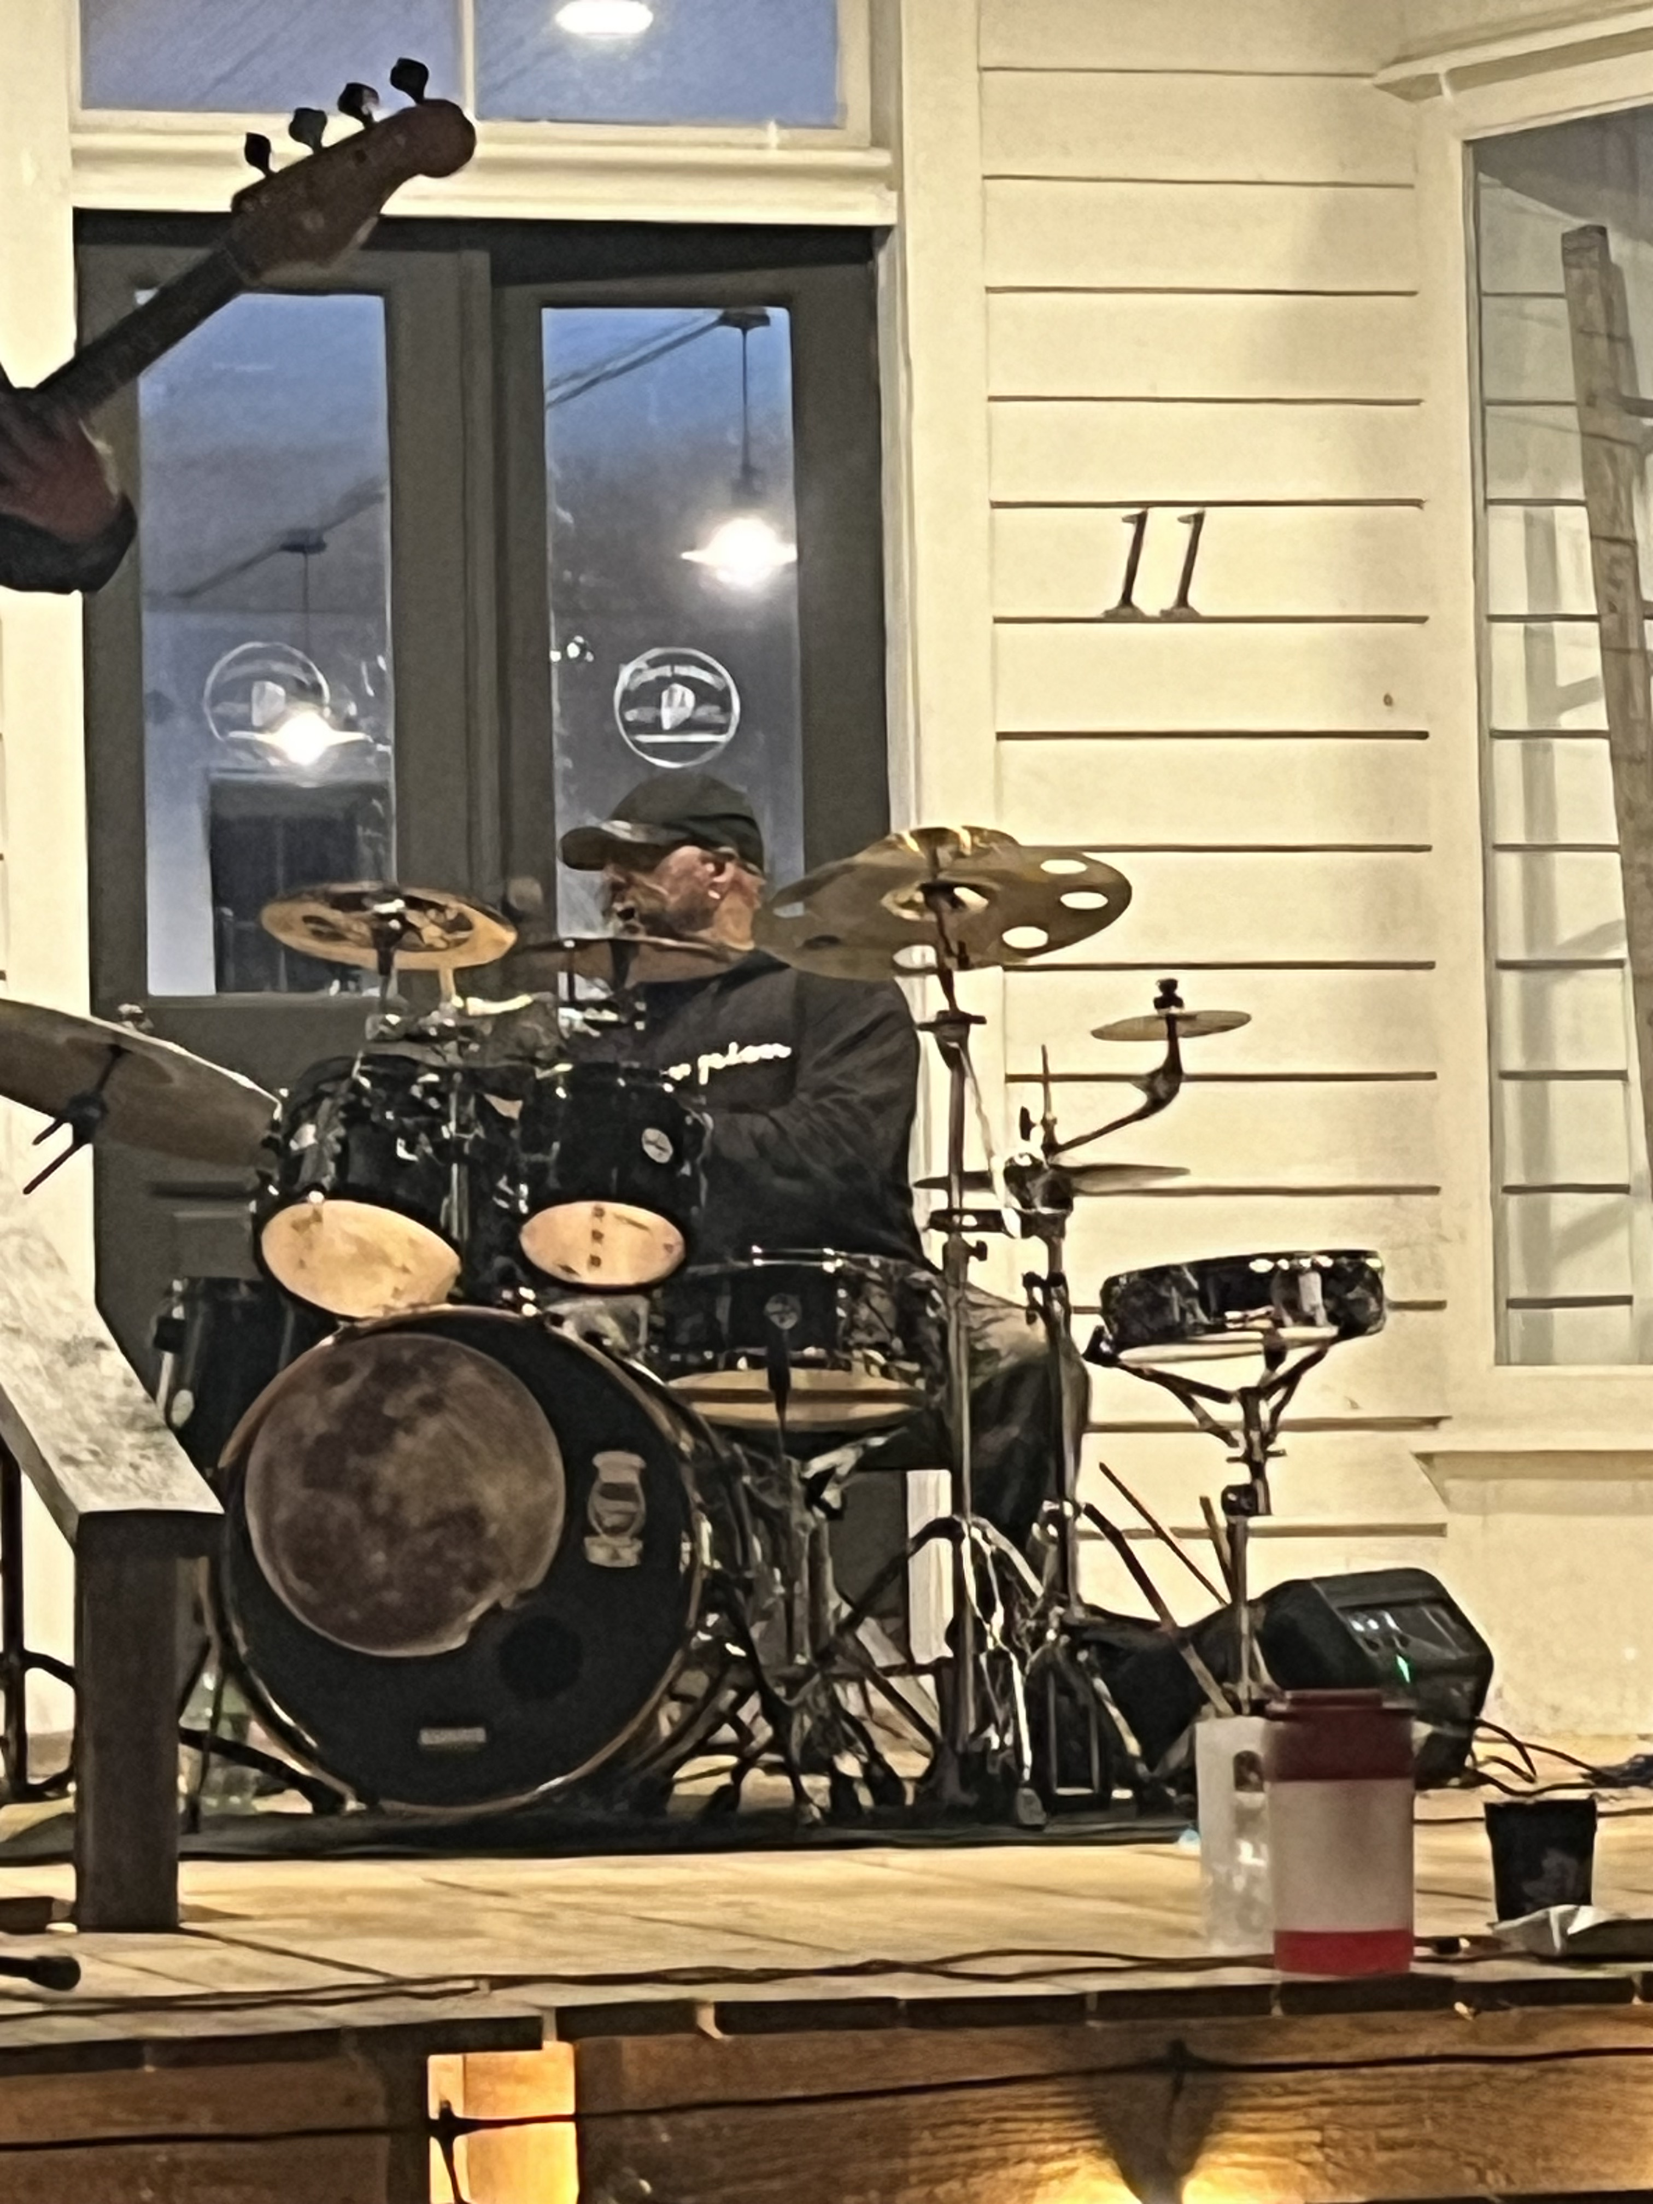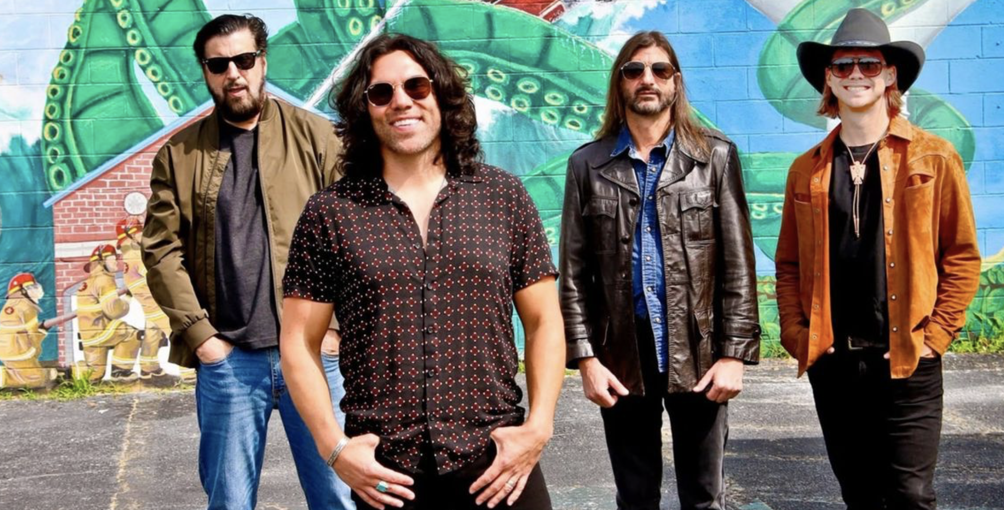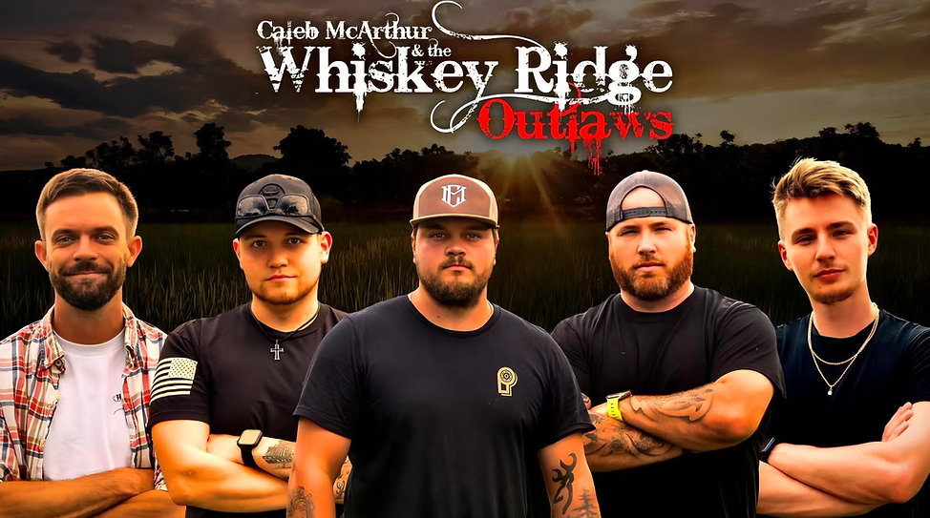

2026 Line Up
Crowded Minds April 25, 2026
Dueling Pianos May 23, 2026
Whiskey Ridge Outlaws July 25, 2026
Chesapeake Sons September 26, 2026
Battle of the Bands October 24, 2025
Each level provides great exposure for your business while supporting a beloved local music series. Let’s work together to bring incredible live music to our community—thank you for considering sponsorship!

Rockin’ the Porch Sponsorship Levels
Headliner Sponsor – $1,800 (SOLD)
- Premier logo placement on all event promotions, including posters, flyers, and digital ads
- Featured sponsor shout-out on stage at every Rockin’ the Porch event
- Prominent logo placement on Kinsale Market above the porch, banner size 4’ by 10’
- Prominent logo placement on KinsaleMarket.com
- A dedicated social media spotlight post and multiple mentions throughout the season
- 8 annual passes to all 5 concerts, VIP glass of wine or beer upon arrival at each event
- Opportunity to set up a promotional booth at events to engage with attendees
Encore Sponsor – $1,200 (2 offerings)
- Logo featured on event materials, including social media and select printed promotions
- Logo placement in front of the stage banner size 2’ by 8’
- 6 annual passes to all 5 concerts, VIP glass of wine or beer upon arrival at each event
- Verbal recognition at each concert
- Business logo on KinsaleMarket.com sponsor page
- A dedicated sponsor highlight post on social media
Opening Act Sponsor – $500
- Logo included in sponsor listing on KinsaleMarket.com
- Logo placement at the event, banner size 3’ by 5’
- 2 annual passes to all 5 concerts, VIP glass of wine or beer upon arrival at each event
- Social media shout-out thanking your business for its support
- Recognition during event announcements

